LETTER OF INTENT (/P/O)

Reference No.

Fax Email Phone

- To be completed on buyer's letterhead –

To: Omayah Group
Care Of Dr.Reyad
(CEO)
Fax :+97124457119
aareyad@hotmail.com
http://omayahdubai.synthasite.com/
P.O.BOX 303
Abu Dhabi-Dubai- Ajman,
United Arab Emirates
UAE

LETTER OF INTENT TO BUY ________________________

WE,THE UNDERSIGNED ________________________________, ACTING WITH FULL LEGAL AND CORPORATE AUTHORITY AND RESPONSIBILITY CONFIRM THAT WE ARE READY, WILLING AND ABLE TO ENTER INTO A CONTRACTUAL AGREEMENT WITH Omayah Group TO PURCHASE THE FOLLOWING COMMODITY:

COMMODITY : Engine Oil _ Grease_ Brake Fluid

ORIGIN : UNITED ARAB EMIRATES

SPECIFICATIONS :…

Products Code (Examples) | 6 X 4L TH | 6 X 4L SH | 6 X 5L TH | 6 X 5L SH | 24 X 1 Ltr | 24 X 500ml | 12 X 1Ltr | 20 Ltr | 200L NSD | Quantity Cartons
10W-40 SM (S Synth) |  |  |  |  |  |  |  |  |  | 100
10W-40 SL/CF (F Synth) |  |  |  |  |  |  |  |  |  | 200
SAE 20W50 SF/CD |  |  |  |  |  |  |  |  |  | 100
SAE 40 SF/CD |  |  |  |  |  |  |  |  |  | 100
ATF Type A |  |  |  |  |  |  |  |  |  | 100
ATF Dexron III |  |  |  |  |  |  |  |  |  | 100
Gear Oil 90 GL4 |  |  |  |  |  |  |  |  |  | 200
Gear Oil 90 GL5 |  |  |  |  |  |  |  |  |  | 50
Total |  |  |  |  |  |  |  |  |  | 950
SH = Side Handle Plastic Cans (Sample Picture)
TH = Top Handle Plastic Cans (Sample Picture) 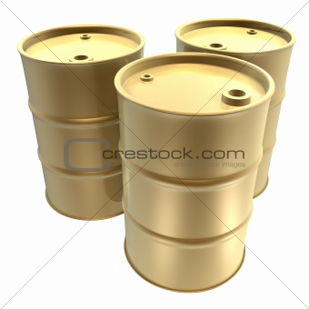
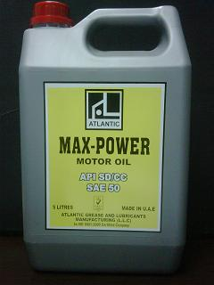
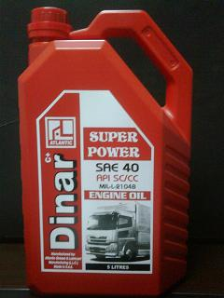
NSD = New Steel Drums
RCD = Reconditioned Drums
DESTINATION PRORT / COUNTRY :

PAYMENT: IRREVOCABLE, CONFIRMED BY A TOP 100 WESTERN WORLD BANK.

Bank Details:

Confirming Bank Details:

WE UNDERSTAND THAT ANY AND ALL OFFERS AND/OR CONTRACT ARE SUBJECT TO SUCCESSFUL SELLER VERIFICATION OF FUNDS AVAILABILITY. WE HEREBY GIVE PERMISSION FOR THE SELLER TO CONDUCT A SOFT PROBE OF OUR ACCOUNT IF REQUIRED.

Kindly you are requested to issue Performa invoice (P/I).

SIGNATURE:_________________________________ (SEAL)

TITLE:_______________________________________

